AGREEMENT

Dear Solokha Andrey Valerievich,

I hope this letter will find you well.

As I mentioned in our discussion, in exchanges with some buyers, we'd like to clarify a couple of aspects with you.

One of our former suppliers, with whom we have worked successfully in the past, is based in Singapore, so we need to comply with official requirements in order to move forward.

Mr Solokha, if you don't mind, could you please provide us with the following documents:
1. Certificate of Registration of Legal Entity / Corporate Body
2. Certificate of Tax Registration
3. Article of Association or/ Memorandum of Association
4. Extract from Russian State Register of Legal Entities
5. Information Letter from Russian Federal Agency of statistics
6. Licenses (if any)
7. Copy of passport of the director of Company

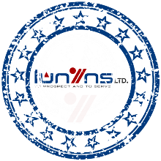

We know that these are sensitive documents, which is why we want to establish a clear and secure environment by signing a mutual non- circumvention agreement. If you agree, please find enclosed the document for you to read and sign at your discretion.

Sir, this document will be part of the set of documents we will send to our bank after the successful sale. It must therefore include accurate information, your signature and a copy of your passport.

Mr Solokha, we are very happy to do business with you. We very much look forward to a long-term relationship.

Thank you very much.

If you need anything else, feel free to come back to us, we will be happy to help.

Best regards
LUBAMBU TSHILOMBO
Director
